**IS 698 Special Topics in Information Systems**

**Lab Guide: Creating and terminating an EC2 Instance Using AWS CLI and Python Boto3**

**Lab 2c**

**Step 1: Create an EC2 Instance Using AWS CLI**

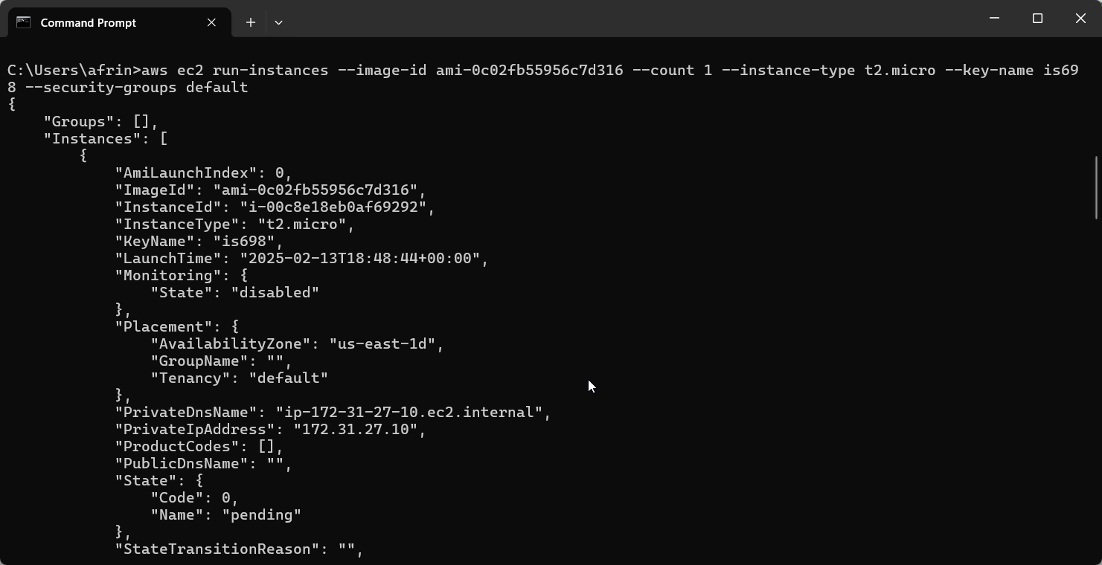

**Step 2: Verify the Running Instance**

**Step 3: Terminate the EC2 Instance Using AWS CLI**

**Instance id - i-00c8e18eb0af69292**

**Part 2: Create and Terminate EC2 Instance Using Python Boto3**

**Created instance with ID: i-0e2cc5e70593e4437**

**Step 2: Terminate EC2 Instance Using Python Boto3**

**Verification and Cleanup**

